**The analysis of Order_amount**

**----Siyu Zhou**

As I said in brief in “final answer” input box, shop 78 and 42 are special cases. In opinions,  
these two shops need special data analysis which cannot be analysis together with other 98 shops. In this analysis, I will show what I thought about order_amount of these 98 shops through data visualization. All my analysis was done by R and Tableau. All my code for this dataset are in my Github (https://github.com/Siyu-Zhou/Data-Science/tree/master/command-for-shopify-dataanalysis).

Firstly, even if excludes special shops, standard deviation is 155.9411 which means VOA of 98 shops also cannot reflect this dataset properly. Density plot(Figure-1) gives a general awareness of the distribution of order_amount. I also add the values of median and average to make this picture more informative. Histogram(Figure-2) has the ability to show more details of distribution. It not only shows the concrete frequency of order-amount but also shows that [150,200] interval has the highest frequency with 947.

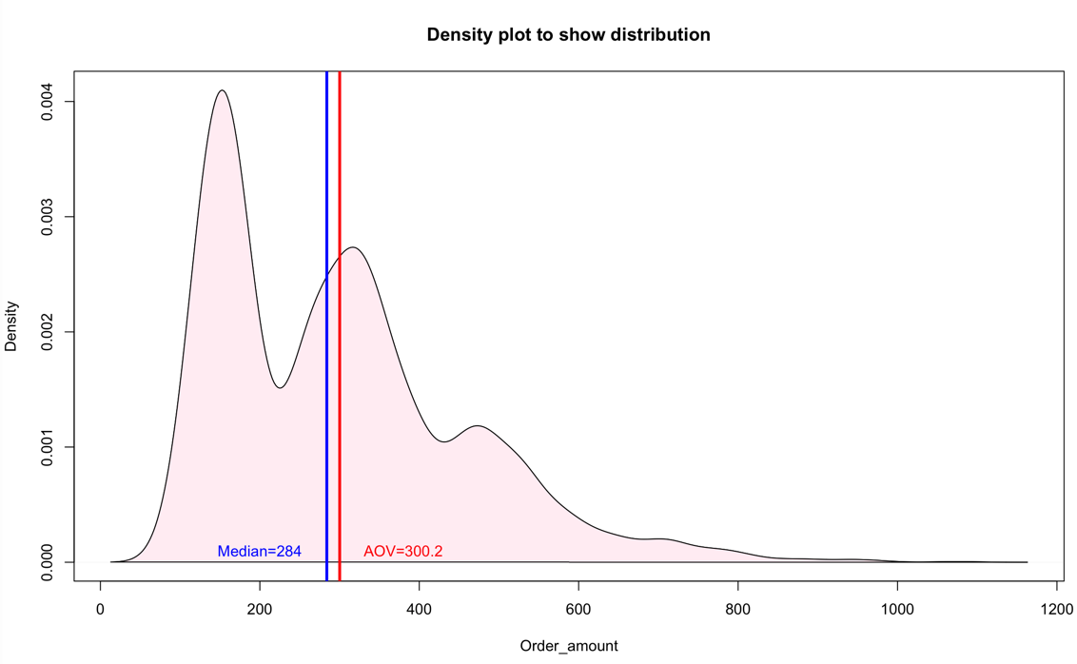

Figure-1

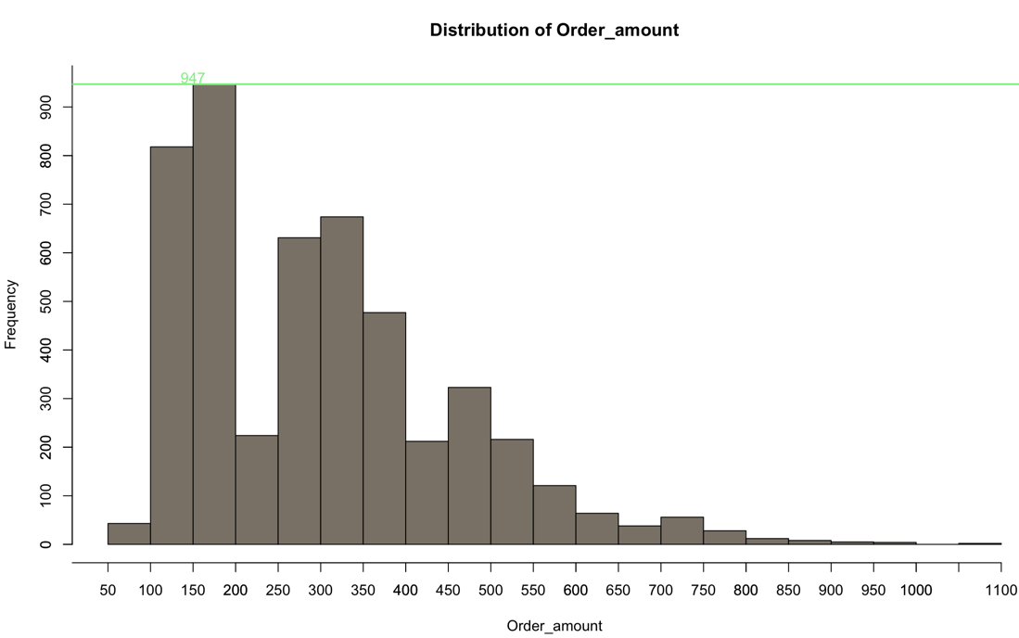

Figure-2

Secondly, I think it also should statistic the sum value of orders for each shop. This is more useful to reflect shops’ business situation rather than analysis data for one order. Shopify can treat low-income shops as the target to provide some services to help those shops increase the sum of order-mount.

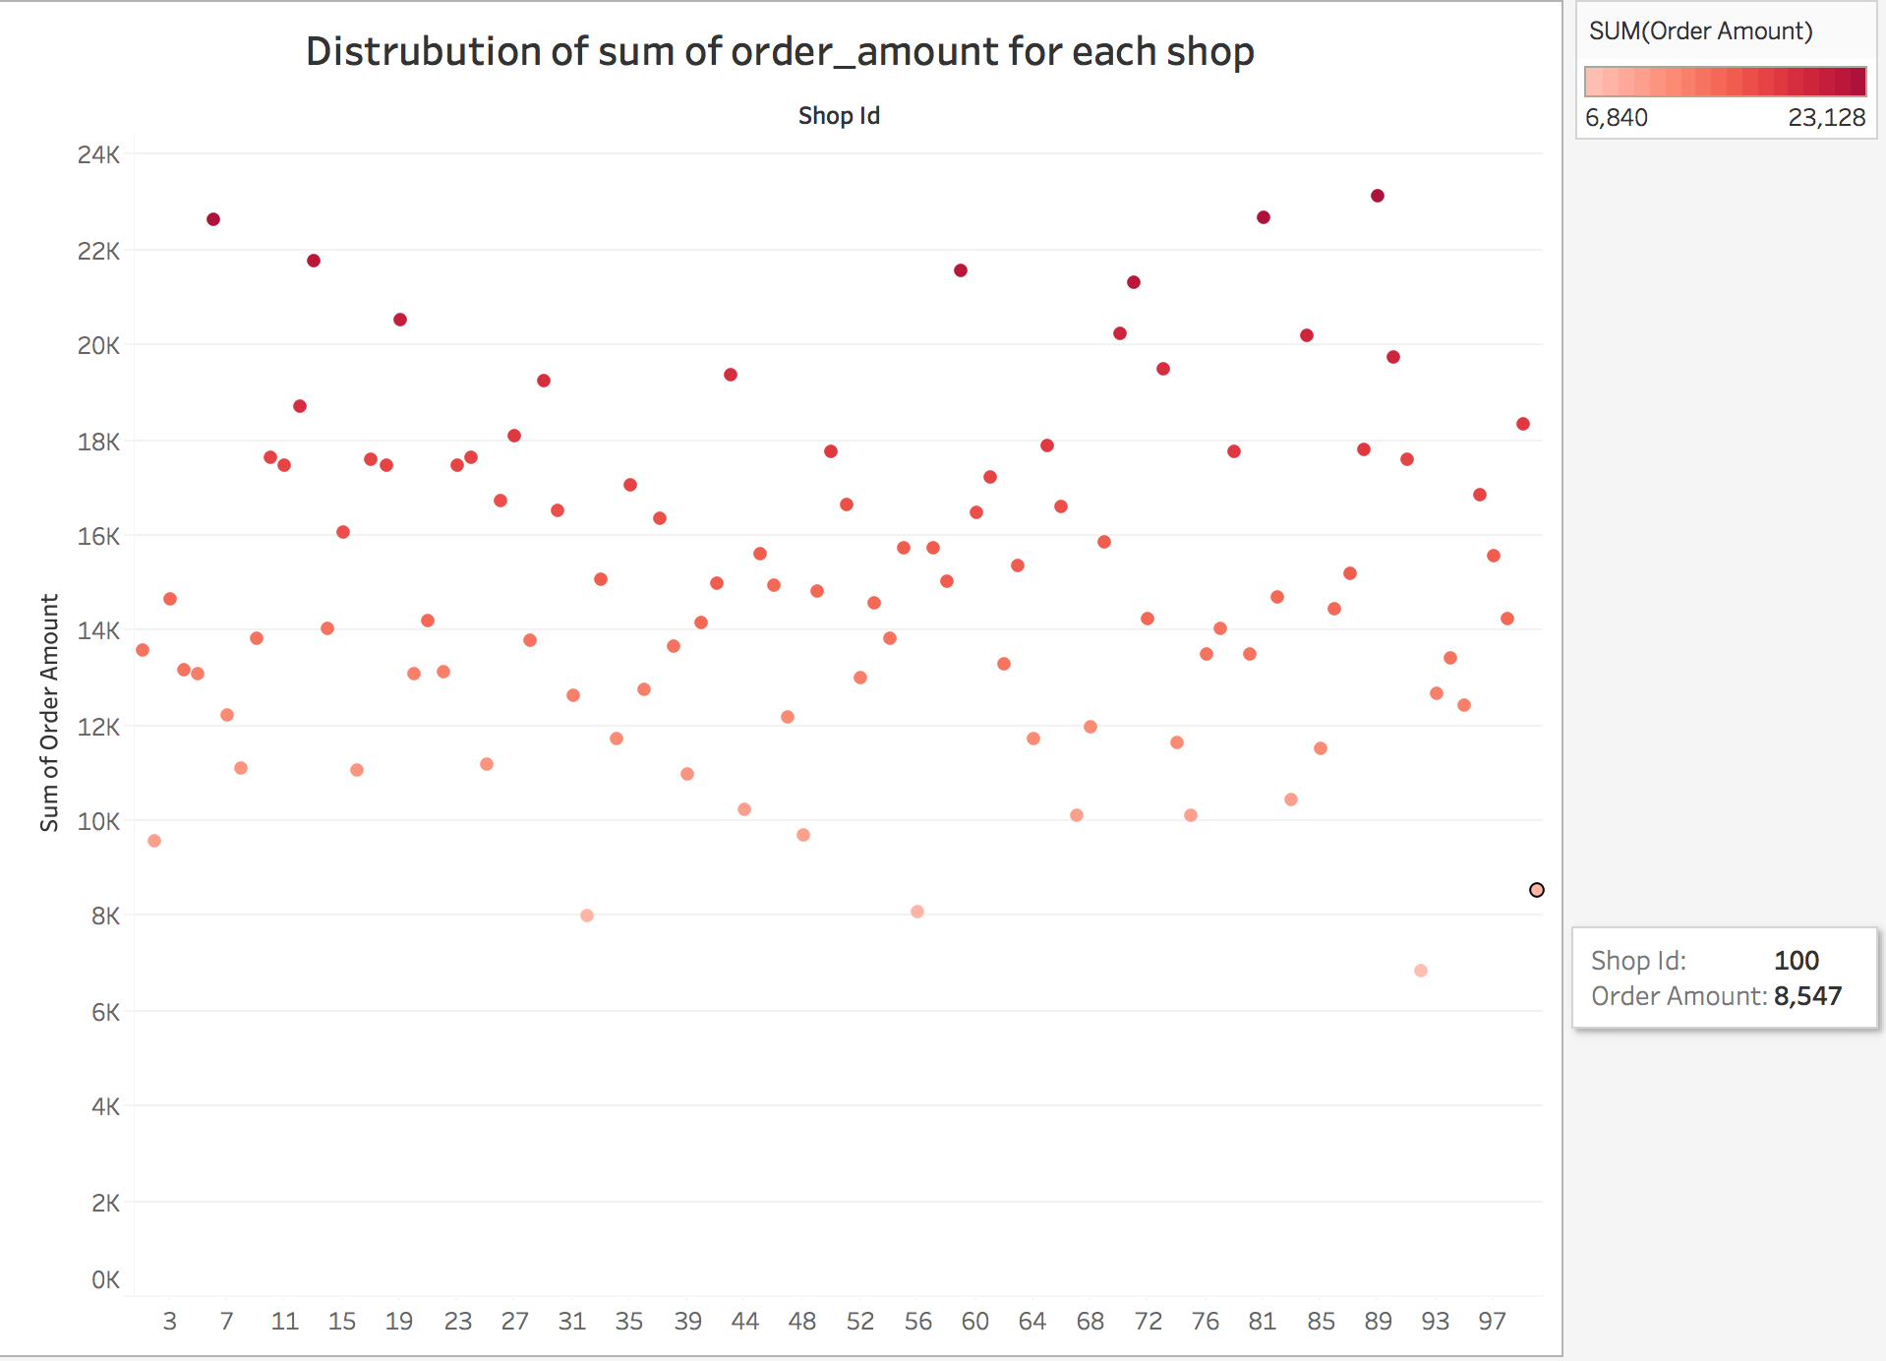

Thirdly, I think this dataset can give me some other useful information rather than order_amount, for example business type, how to guarantee the stable of website when customer use shopify payment method. Since the requirement is just for order-amount I will not state here.

From what has been stated above, I show my brief and humble opinions about the analysis of this dataset.